Develop a vb project to display a calendar using flex grid

Form design:

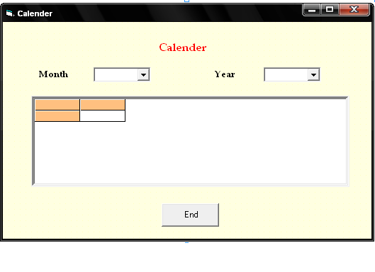
Properties

Controls | Name | Caption
Combo1 | Cm
Combo2 | Cy
MSFlexgrid | C
Command1 | Cmdend | End

9.Calender
Aim:
To develop a vb project to display a calendar using flex grid

Coding:
Dim mon(1 To 12) As String
Dim day(1 To 12) As Integer
Dim y, m, i As Integer

Private Sub cm_Click()
If (cm.ListIndex >= 0) Then
m = cm.ItemData(cm.ListIndex)
Call display
End If
End Sub

Private Sub Cmdend_Click()
End
End Sub

Private Sub cy_Click()
If (cy.ListIndex >= 0) Then
y = Val(cy.Text)
Call display
End If
End Sub

Private Sub Form_Load()
mon(1) = "January"
mon(2) = "Feburary"
mon(3) = "March"
mon(4) = "April"
mon(5) = "May"
mon(6) = "June"
mon(7) = "July"
mon(8) = "August"
mon(9) = "September"
mon(10) = "October"
mon(11) = "November"
mon(12) = "December"

day(1) = 31
day(2) = 28
day(3) = 31
day(4) = 30
day(5) = 31
day(6) = 30
day(7) = 31
day(8) = 31
day(9) = 30
day(10) = 31
day(11) = 30
day(12) = 31

For i = 1 To 12
cm.AddItem (mon(i))
cm.ItemData(cm.NewIndex) = i
Next i

For i = 2000 To 2050
cy.AddItem (i)
Next i
Call align
End Sub

Private Sub align()
c.Cols = 7
c.FixedRows = 1
c.FixedCols = 0

For i = 0 To 6
c.ColWidth(i) = 950
Next i

c.TextMatrix(0, 0) = "SUNDAY"
c.TextMatrix(0, 1) = "MONDAY"
c.TextMatrix(0, 2) = "TUESDAY"
c.TextMatrix(0, 3) = "WEDNWSDAY"
c.TextMatrix(0, 4) = "THURSDAY"
c.TextMatrix(0, 5) = "FRIDAY"
c.TextMatrix(0, 6) = "SATURDAY"
End Sub

Private Sub display()
If y > 0 And m > 0 Then
If (y Mod 4 = 0 And (y Mod 100 <> 0) Or (y Mod 400)) Then
day(2) = 29
End If
d = 0
For i = 1 To m - 1
d = d + day(i)
Next i
d = (((Int(CDbl(y - 1)) * 365.25) + d) Mod 7)
x = 1
c.Clear
Call align
c.Rows = 2
For i = 1 To day(m)
If (d > 6) Then
d = 0
x = x + 1
c.Rows = c.Rows + 1
End If
c.TextMatrix(x, d) = i
d = d + 1
Next i
End If
day(2) = 28
End Sub

Output:

